CEC2025 Competition on Dynamic Optimization Problems
2025 IEEE Congress on Evolutionary Computation
8-12 June 2025, Hangzhou, China

Overview and Aim:
The search space of many real-world optimization problems is dynamic, with changes in objective functions, variables, and/or constraints. Dynamic optimization problems (DOPs) require solutions to adapt over time as the environment evolves, often necessitating online optimization methods. Algorithms tackling DOPs must not only identify desirable solutions but also respond promptly to environmental changes and quickly adapt when existing solutions become suboptimal. This competition focuses on evolutionary dynamic optimization methods (EDOs) for unconstrained single-objective continuous DOPs. EDOs represent a crucial class of algorithms, serving as a foundation for more advanced methods applied in robust, large-scale, and constrained dynamic optimization. The competition aims to provide a unified platform for the fair and straightforward evaluation of EDOs. Participants are invited to test their algorithms on problem instances generated by the generalized moving peaks benchmark (GMPB) [1], which features a range of dynamic characteristics and difficulty levels.
In this competition, the anticipated number of participants will be between 10 and 20. The participants are encouraged to design the novel and powerful EDOs to promote the development of dynamic optimization.

Test Problem - Generalized Moving Peaks Benchmark:
GMPB is designed to test the performance of optimization algorithms on dynamic and complex environments. The landscapes generated by GMPB consist of multiple promising regions, each with a variety of controllable characteristics. These characteristics range from unimodal to highly multimodal, symmetric to highly asymmetric, smooth to highly irregular, and include varying degrees of variable interaction and ill-conditioning. Such diversity makes GMPB an effective tool for modeling a wide range of dynamic behaviors and challenges encountered in real-world optimization problems.
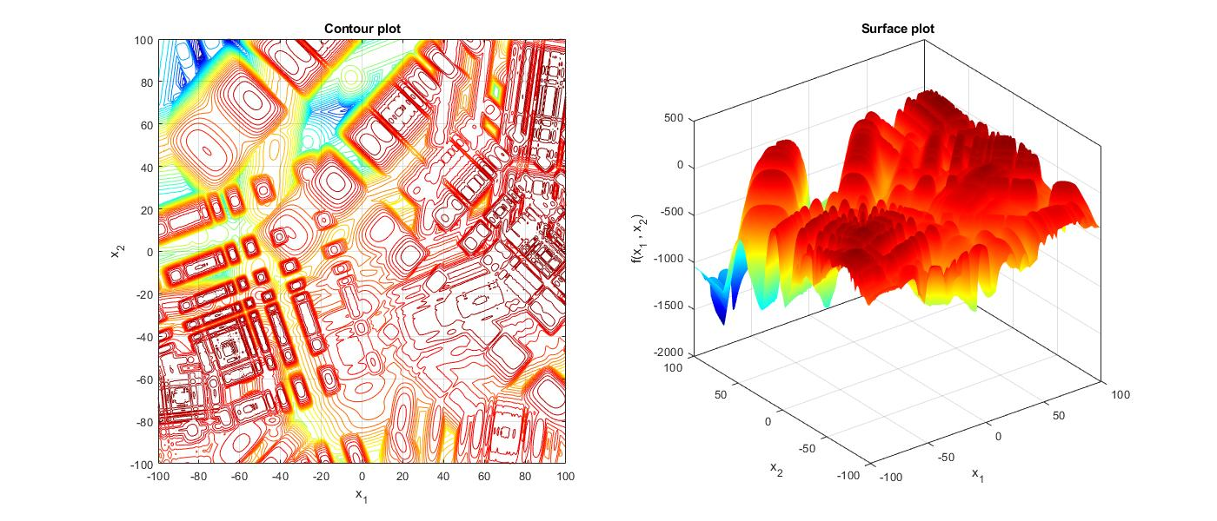
Figure 1: Contour and surface plots of a landscape generated by GMPB
An example of a 2-dimensional landscape generated by GMPB is shown in Figure 1, illustrating its ability to create challenging and dynamic scenarios. This allows researchers to systematically evaluate the adaptability and efficiency of evolutionary dynamic optimization algorithms under different levels of complexity and change. For a detailed description of GMPB, the reader is referred to the competition support document (https://arxiv.org/abs/2106.06174). The MATLAB source code for GMPB is accessible through the EDOLAB platform and can be downloaded from EDOLAB's GitHub repository (https://github.com/Danial-Yazdani/EDOLAB-MATLAB). Researchers are encouraged to utilize the guidelines in [2] to integrate their own algorithms into EDOLAB.

Problem Instances:
12 different problem instances with different characteristics are used in this competition. To generate these problem instances, the participants need to set four parameters PeakNumber, ChangeFrequency, Dimension, and ShiftSeverity in “main.m” according to the values shown in Table 1.
Table 1: Parameter setting of the 12 problem instances used in this competition.
Parameter | F1 | F2 | F3 | F4 | F5 | F6 | F7 | F8 | F9 | F10 | F11 | F12
PeakNumber | 5 | 10 | 25 | 50 | 100 | 10 | 10 | 10 | 10 | 10 | 10 | 10
ChangeFrequency | 5000 | 5000 | 5000 | 5000 | 5000 | 2500 | 1000 | 500 | 5000 | 5000 | 5000 | 5000
Dimension | 5 | 5 | 5 | 5 | 5 | 5 | 5 | 5 | 10 | 20 | 5 | 5
ShiftSeverity | 1 | 1 | 1 | 1 | 1 | 1 | 1 | 1 | 1 | 1 | 2 | 5
RunNumber | 31
EnvironmentNumber | 100

Evaluation Criteria and Ranking Calculation:
Offline error is used as the performance indicator in this competition:
$$E_{o}= \frac{1}{Tϑ}\sum_{t=1}^{T}{\sum_{c=1}^{ϑ}{ϑ\left.\left(f^{\left(t\right)}({\vec{x}}^{∘(t)})- f^{\left(t\right)}({\vec{x}}^{*\left(\left(t-1\right)ϑ+ c\right)})\right.\right)}}$$
where ${\vec{x}}^{∘(t)}$ is the global optimum position at the $t$-h environment, $T$ is the number of environments, $ϑ$ is the change frequency, $c$ is the fitness evaluation counter for each environment, and ${\vec{x}}^{*\left(\left(t-1\right)ϑ+ c\right)}$ is the best found position at the $c$-th fitness evaluation in the $t$-th environment. Offline error is the average of current error values over optimization process. In the source code, in each run, the values of the current errors are stored in “Problem.CurrentError” at the end of each run, the offline error is obtained.
We will conduct a Wilcoxon rank-sum test on $E_{o}$ to compare the results at a 95% confidence level. The outcomes marked with "w" suggest that our algorithm performs significantly better than others, while "l" indicates it performs significantly worse, and "t" means it is equivalent to its peers. We will calculate the sum of the "w-l" values across all 12 instances to determine each algorithm's score, and then rank the performance of the algorithms based on these scores.
$$score=\sum_{i=1}^{12}{(w_{i}-l_{i}})$$

Rules:
- Participants are NOT allowed to change the random seed generators in the code.
- Participants are NOT allowed to modify “BenchmarkGenerator.m” and “fitness.m” files in the source code.
- Participants are NOT allowed to tune the parameters of their algorithm for individual problem instance. In other words, the values of the parameters of the algorithm must be the same for solving all problem instances.
- The problem instances must be considered as complete black-boxes and the algorithms must NOT use any of the internal parameters of GMPB.
- The algorithm can be informed about the environmental changes. Consequently, participants do not need to use any change detection mechanism in their algorithms. Note that it is also accepted if a change detection component is used.
- Each participant can submit more than one algorithm.
- Competitors can participate with either newly proposed algorithms (unpublished) or their previously published algorithms.
- Winners will be required to share their algorithm's source code for result verification. This code will remain confidential and will not be published.

Submission Guidelines:
For each algorithm, the competitors must provide a compressed folder (named as the algorithm's name) which contains 13 files. The first file is a document containing the following information:
- Title
- Names, affiliations, and emails of participants
- A short description of the algorithm, including the used optimizer (e.g., PSO or DE), how the population is managed and controlled (e.g., bi-population, multi-population with fixed number of sub-populations, or multi-population with clustering), and whether explicit memory (archive) is used or not.
- The following Table 2 which shows the best, worst, average, median, and standard deviation of the offline error values obtained by 31 runs for each problem instance.
Table 2: The results obtained by 31 runs for each problem instance.
Parameter | Problem instances
Parameter | F1 | F2 | F3 | F4 | F5 | F6 | F7 | F8 | F9 | F10 | F11 | F12
Best
Worst
Average
Median
Standard deviation

Important Dates:
For participants planning to submit a paper to the 2025 IEEE Congress on Evolutionary Computation:
Paper submission: 15 Jan 2025
Paper Acceptance Notification: 15 Mar 2025
Final Paper Submission & Early Registration Deadline: 24 May 2025
Paper final notifications: 31 Mar 2025
Participants for competition only:
Results submission deadline: 19 May 2025
Note: Please send your results directly to Mr. Mai Peng (pengmai1998@gmail.com)

Competition Organizers:
Changhe Li
School of Artificial Intelligence, Anhui University of Science & Technology, Hefei, China
Email: changhe.lw@gmail.com

Mai Peng
School of Automation, China University of Geosciences, Wuhan, China
Email: pengmai1998@gmail.com

Guoyu Chen
School of Artificial Intelligence, Anhui University of Science & Technology, Hefei, China
Email: chenguoyumail@163.com

Danial Yazdani
Business Intelligence Team, WINC, Australia
Email: danial.yazdani@winc.au.com

Michalis Mavrovouniotis
Cyprus University of Technology, Lemesos, Cyprus
Email: michalis.mavrovouniotis@eratosthenes.org.cy

Wenjian Luo
Guangdong Provincial Key Laboratory of Novel Security Intelligence Technologies, School of Computer Science and Technology, Harbin Institute of Technology and Peng Cheng Laboratory, Shenzhen 518055, China
Email: luowenjian@hit.edu.cn

Shengxiang Yang
Institute of Artificial Intelligence (IAI), School of Computer Science and Informatics, De Montfort University, Leicester LE1 9BH, United Kingdom
Email: syang@dmu.ac.uk

References:
- D. Yazdani, M. N. Omidvar, R. Cheng, J. Branke, T. T. Nguyen, and X. Yao, “Benchmarking continuous dynamic optimization: Survey and generalized test suite,” IEEE Transactions on Cybernetics, vol. 52(5), pp. 3380-3393, 2020.
- M. Peng, Z. She, D. Yazdani, D. Yazdani, W. Luo, C. Li, J. Branke, T. T. Nguyen, A. H. Gandomi, S. Yang, Y. Jin, and X. Yao, “Evolutionary dynamic optimization laboratory: A matlab optimization platform for education and experimentation in dynamic environments,” arXiv preprint arXiv:2308.12644, 2023.

